Year 8 Mini Test 4
Geometry - Congruent Triangles, transformations and angle properties.

Name : ______________________________ Score: _______/32 Marks

Show working and answers on this sheet. Show ALL working in sufficient detail to support your answers. Incorrect answers without supporting reasoning may be allocated zero marks.

Time allocated 35 mins
- For each set of three triangles below, determine which of the three triangles are congruent, state which rule proves they are congruent and write a statement of congruence. (Marks = 3,3,3,3)

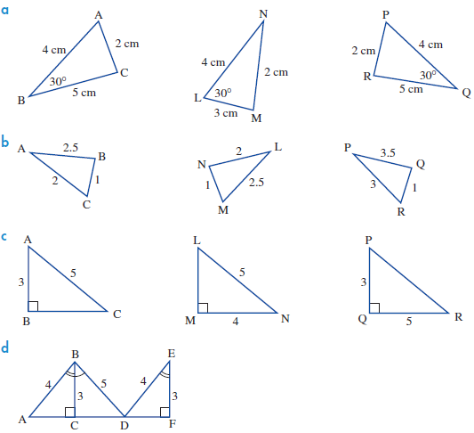
[3 Marks]



[3 Marks]


C

[3 Marks]

- Given that each set of triangles below are congruent to each other, find the missing values.
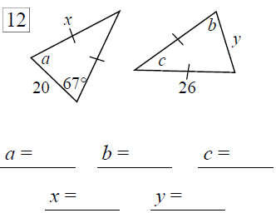
- B)
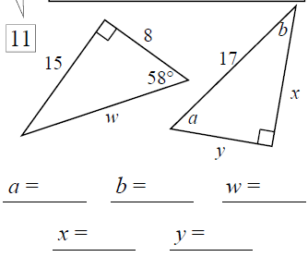
[5 Marks]
[5 Marks]

- Circle yes or no if these are a valid test for congruence between 2 triangles
- All sides of are the same length on both triangles - Yes/No

- All angles are the same size on both triangles - Yes/No

- 2 sides and the angles between them are the same on both triangles - Yes/No

- Both triangles have right angles, the hypotenuse is the same size and 1 other side is the same length. - Yes/No

- 2 sides are the same length and 1 angle is the same size on both triangles - Yes/No
[5 marks]

- Explain which rule of congruence proves that each of the following pictures is made from 2 congruent triangles.

a)
[2 marks]
b)
[2 marks]
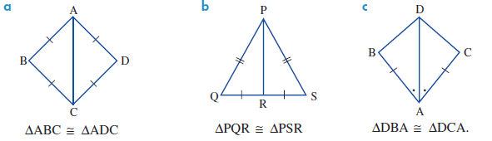



- Prove that the pair of triangles below is congruent and hence find the value of the value marked with an x.
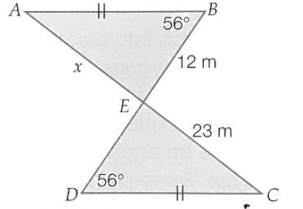

[4 Marks]
End of test

